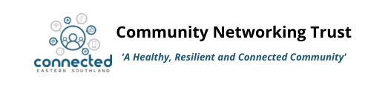
CLIENT REFERRAL FORM
Here at Connected Eastern Southland we provide space for a number of community organisations working locally. We also have a range of social and community services managed onsite. Please use this form to refer a client to one or more of the services below. Complete the relevant sections of this form and email it to referrals@cnt.org.nz . Please note; the client care team may discuss this referral to ensure the whanau/young person receive the best service for their current needs.
“Right Service, Right Time”

Service | Description of Service | Service Required
Strengthening Families Coordinator | For whanau needing support and coordination while working with multiple agencies
Whanau Navigators | Whanau support service, goal setting, pathway planning, advocacy, mentoring, linking with services
Youth Workers | - Supporting young people aged 5-24yrs and their whanau to achieve positive outcomes.  - Education, training, goal setting and pathway support available 16-24 year olds
Community Connector | Assistance and Support for anyone including:  - Completing and understanding forms and documents  - Booking and attending appointments  - Connecting to the right services  - Information and advice  - Covid-19 assistance and support for those impacted by Covid-19

SECTION 1 Referrer Details

Date of referral: / /

Referred by: Agency/service:

Phone: Email:

Signature/eSignature

SECTION 2 Client Details

Name: Age:

Date of Birth: Gender:

Address:

Ethnicity: Iwi:

Phone Number: Email address:

Name of current school:

If young person is 16 or under:
Parent/Caregiver: Relationship to young person:

Address: Phone Number:

THE WHANAU AND/OR YOUNG PERSON GIVE CONSENT FOR THIS REFERRAL TO BE MADE □
Additional family members:
Name | Birthdate | Age | School

SECTION 3 Reasons for referring

What other agencies are working with this individual/whanau?

Current Situation

